Project 2

Create a Pre-Req GPA Calculator

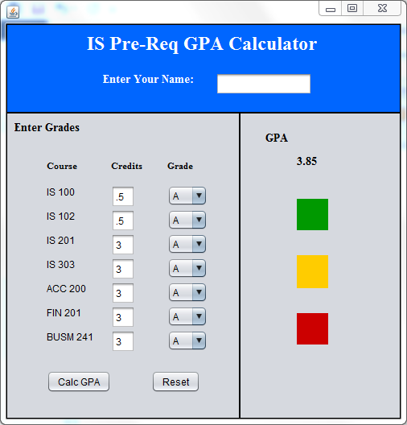

**\*Make sure you use appropriate names for the components. NOTE: All three colored signals are displayed in the screen shot to indicate their position. When you first run the program, no signals will be displayed until the Calc GPA button is clicked**

**YOU MAY CHANGE THIS TO USE IS 110 for 1 CREDIT INSTEAD OF IS 100 and IS 102 IF YOU WOULD LIKE.**

Panel (located at the top of the frame)

* Background color blue
* Line border

Label in the Top Panel

* Font is Times New Roman
* Font is Bold
* Text is “IS Pre-Req GPA Calculator”
* Size is 24
* Foreground color is white

Add another label in the Top Panel

* Foreground color is white
* Text is :” Enter Your name:”
* Font is Bold
* Font size is 14
* Font is Times New Roman

Add a Text Field to the right of the previously added Label

* Clear the text

Panel on the left side of the frame and below the top panel

* Line border

Label on Panel on the left

* Text is “Enter Grades”
* Font is Bold
* Font size is 14
* Font is Times New Roman

Add labels in the Panel on the left for:

* IS 100
* IS 102
* IS 201
* IS 303
* ACC 200
* FIN 201
* BUSM 241

Add text boxes to the left panel and to the left of each of the labels representing the credits for each course

* Add default credit values to the text fields

Add combo boxes to the left panel representing each of the courses

* Modify the Models property to include the Grades A, A-, B+, B, B-, C+, C, C-, D+, D, D-, and E

Add labels for the Course column, Credit column, and Grade column

* Add Text as shown in diagram

Add a button to the left panel below the labels and combo boxes

* Text should be “Calc GPA”
* Write an on click event to calculate the GPA and display the appropriate traffic light panel
* Here is the information to calculate the GPA:
  + IS 100 – credit .5
  + IS 102 – credit .5
  + IS 201 – credit 3
  + IS 303 – credit 3
  + ACC 200 – credit 3
  + FIN 201 – credit 3
  + BUSM 241 – credit 3
  + A = 4
  + A- = 3.7
  + B+ = 3.4
  + B = 3
  + B- = 2.7
  + C+ = 2.4
  + C = 2
  + C- = 1.7
  + D+ = 1.4
  + D = 1
  + D- = .7
  + E = 0
  + Formula = Sum of Course Credit * Course grade divided by total credits
  + The total credits needs to be dynamically calculated. IOW, don’t hardcode a variable to have the total number of credits of 16. You need to add up the values in all of the text fields
  + NOTE: The Double.parseDouble method will convert a string to a double. For example:

dCredit = Double.parseDouble(txtIS100.getText());

Add a button to the left panel below the labels and combo boxes and to the right of the Calc button

* Text should be “Reset”
* Write an on click event to reset the combo boxes to “A” grades, set the GPA label value to “0.00”, hide all of the traffic light panels, and clear the name text field
* You should also set the cursor in the txt field by calling the requestFocus() method
  + txtName.requestFocus();

Add another panel below the top panel and to the right of the other panel

* Line border

Add a label to this right panel

* Font is Times New Roman
* Font is Bold
* Text is “GPA”
* Size is 14

Add a label in the right panel

* Font is Times New Roman
* Font is Bold
* Text is “empty”
* Size is 14
* This label will be used to display the GPA
* Make sure that when you change this text value, the GPA is rounded to a 2 decimal value – Google this one. I showed it in class a long time ago but you need to figure this one out without asking the TAs. HINT: DecimalFormat class

Add three panels to the right panel

* Each one will be a small box and represent Green, Yellow, or Red (like a traffic light). The green will be on top, the yellow in the middle, and the red on the bottom (initially, all will have the same color as the panel but I have shown you the colors in the screen shot to display the location and size)

**NOTE: These values are for simulation purposes only and do NOT reflect current IS admissions standards**

* If the GPA is 3.7 and above, display the green panel only
* If the GRP is 3.2 and above, display the yellow panel only
* Otherwise display the Red panel only

**CREATE A METHOD TO CALCULATE THE GPA**

* **Receives 2 parameters**
  + **One for the letter grade of the course (from the combobox)**
  + **One for the number of credits for the course (from the textfield)**
  + **Use the String.valueOf() method to convert a double to a string**
    - **String.valueOf(cmbIS100.getSelectedItem())**
  + **Use the Double.parseDouble() method to convert a string to a double**
    - **Double.parseDouble(txtIS100.getText())**

**You might want to do more than what is required but in this case, please follow the requirements. Make sure you document your code**